1998 Montessori Education Week Design by Ashleigh, Age 10,
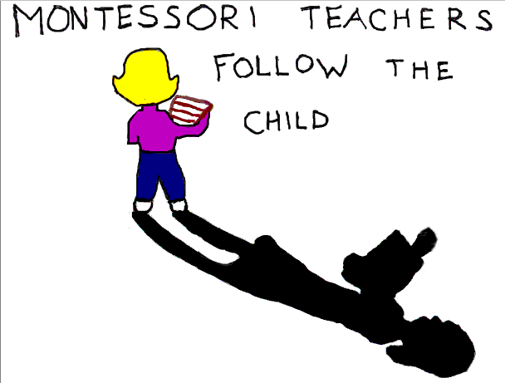
Hudson Montessori School, Hudson, Ohio

The Montessori Educator

“The first duty of the educator, whether he is involved with the newborn infant or an older child, is to recognize the human personality of the young being and respect it.”
Maria Montessori - The Absorbent Mind

Montessori Education Week
February 26 – March 4, 2023

For more information contact or visit your local Montessori School

School Name and address __________________________________________________________________

School Telephone and Contact person ________________________________________________________

