Peace Lesson for Montessori Education Week

Title: Characteristics of a Peaceful Person
Age: Early Childhood to adult
Aims:
- characteristics of a Peaceful Person
- new vocabulary
- ways to be a Peaceful Person
- a kind of poetry
- synonyms
- Preparation: background - peaceful relaxing music
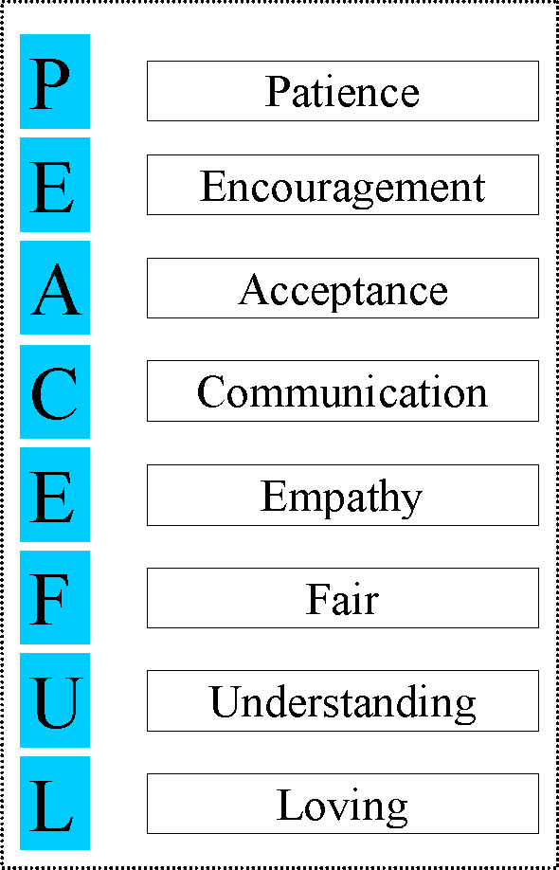
Presentation:
- Gather a group of children
- Pause to listen to the peaceful music
- Show the children the word "Peaceful"
- Ask the children what makes a peaceful person
- Acknowledge their contributions
- Show the children the letter "P" ask the children for words that begin with "P" that describe a peaceful person
- Record the words and place them beside the "P"
- Continue - show the next letter - the "E"
- Again, ask for words that begin with "E" that make a peaceful person
- Continue with each letter until you have spelled out PEACEFUL
See sample layout to the left
Title: Characteristics of a Peaceful Person
Age: Early Childhood to adult
Aims:
- characteristics of a Peaceful Person
- new vocabulary
- ways to be a Peaceful Person
- a kind of poetry
- synonyms
              - Preparation: background - peaceful relaxing music

Points of Interest:
- the music
- the words next to the correct letter
- describing peaceful people or things
Control of Error: Large letters P E A C E F U L and words matching to them begin with the same letter
Language: any words that children or you share
Variations and Extension - use your imagination and creativity
- Letters and words created can be placed on the shelf in a basket for children to take out and match again by themselves
- Children can copy the letters and the words in their notebook
- children can create their own word PEACEFUL and list words that begin with each letter and record as follows
Source of Lesson: D. Wilder, Montessori Intern with Cleveland Municipal School District, Cleveland, Ohio
Let us hear from you
- Share your Montessori Education Week or Peace lessons or ideas
